NBKRIST
ELECTROMECHANICAL ENERGY CONVERSION – III
LECTURE NOTES
UNIT-5
I.PRABHAKAR REDDY & E.VINOD ARUN KUMAR
DEPARTMENT OF ELECTRICAL AND ELECTRONICS ENGINEERING

SINGLE PHASE INDUCTION MOTOR
Single phase power system is widely used as compared to three phase system for domestic purpose, commercial purpose and to some extent in industrial purpose. As the single phase system is more economical and the power requirement in most of the houses, shops, offices are small, which can be easily met by single phase system. The single phase motors are simple in construction, cheap in cost, reliable and easy to repair and maintain. Due to all these advantages the single phase motor finds its application in vacuum cleaner, fans, washing machine, centrifugal pump, blowers, washing machine, small toys etc.
The single phase AC motors are further classified as:
- Single phase induction motors or asynchronous motors.
- Single phase synchronous motors.
- Commutator motors.
This article will provide fundamentals, description and working principle of single phase induction motor.

Construction of Single Phase Induction Motor
Like any other electrical motor asynchronous motor also have two main parts namely rotor and stator.
Stator:
As its name indicates stator is a stationary part of induction motor. A single phase AC
supply is given to the stator of single phase induction motor.
Rotor:
The rotor is a rotating part of induction motor. The rotor is connected to the mechanical load through the shaft. The rotor in single phase induction motor is of squirrel cage rotor type.
The construction of single phase induction motor is almost similar to the squirrel cage three phase motor except that in case of asynchronous motor the stator have two windings instead of one as compare to the single stator winding in three phase induction motor.

Stator of Single Phase Induction Motor
The stator of the single phase induction motor has laminated stamping to reduce eddy current losses on its periphery. The slots are provided on its stamping to carry stator or main winding. In order to reduce the hysteresis losses, stamping are made up of silicon steel. When the stator winding is given a single phase AC supply, the magnetic field is produced and the motor rotates at a speed slightly less than the synchronous speed N_{s} which is given by
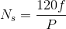
Where,
f = supply voltage frequency,
P = No. of poles of the motor.
The construction of the stator of asynchronous motor is similar to that of three phase induction motor except there are two dissimilarity in the winding part of the single phase induction motor.
- Firstly the single phase induction motors are mostly provided with concentric coils. As the number of turns per coil can be easily adjusted with the help of concentric coils, the mmf distribution is almost sinusoidal.
- Except for shaded pole motor, the asynchronous motor has two stator windings namely the main winding and the auxiliary winding. These two windings are placed in space quadrature with respect to each other.
Rotor of Single Phase Induction Motor
The construction of the rotor of the single phase induction motor is similar to the squirrel cage three phase induction motor. The rotor is cylindrical in shape and has slots all over its periphery. The slots are not made parallel to each other but are bit skewed as the skewing prevents magnetic locking of stator and rotor teeth and makes the working of induction motor more smooth and quieter i.e less noise. The squirrel cage rotor consists of aluminum, brass or copper bars. These aluminum or copper bars are called rotor conductors and are placed in the slots on the periphery of the rotor. The rotor conductors are permanently shorted by the copper or aluminum rings called the end rings. In order to provide mechanical strength, these rotor conductors are braced to the end ring and hence form a complete closed circuit resembling like a cage and hence got its name as squirrel cage induction motor. As the bars are permanently shorted by end rings, the rotor electrical resistance is very small and it is not possible to add external resistance as the bars are permanently shorted. The absence of slip ring and brushes make the construction of single phase induction motor very simple and robust.

Working Principle of Single Phase Induction Motor
NOTE: We know that for the working of any electrical motor whether its AC or DC motor, we require two fluxes as, the interaction of these two fluxes produced the required torque, which is desired parameter for any motor to rotate.
When single phase AC supply is given to the stator winding of single phase induction motor, the alternating current starts flowing through the stator or main winding. This alternating current produces an alternating flux called main flux. This main flux also links with the rotor conductors and hence cut the rotor conductors. According to the Faraday’s law of electromagnetic induction, emf gets induced in the rotor. As the rotor circuit is closed one so, the current starts flowing in the rotor. This current is called the rotor current. This rotor current produces its own flux called rotor flux. Since this flux is produced due to induction principle so, the motor working on this principle got its name as induction motor. Now there are two fluxes one is main flux and another is called rotor flux. These two fluxes produce the desired torque which is required by the motor to rotate.
Double Revolving Field Theory
According to this theory, any alternating quantity can be resolved into two rotating components which rotate in opposite directions and each having magnitude as half of the maximum magnitude of the alternating quantity.
In case of single phase induction motors, the stator winding produces an alternating magnetic field having maximum magnitude of Φ_{1m}.
According to double revolving field theory, consider the two components of the stator flux, each having magnitude half of maximum magnitude of stator flux i.e. (Φ_{1m}/2). Both these components are rotating in opposite directions at the synchronous speed N_{s} which is dependent on frequency and stator poles.
Let Φ_{f} is forward component rotating in anticlockwise direction while Φ_{b} is the backward component rotating in clockwise direction. The resultant of these two components at any instant gives the instantaneous value of the stator flux at the instant. So resultant of these two is the original stator flux.
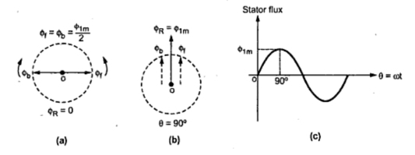
Fig.5 1 Stator flux and its two components
The Fig. 5.1 shows the stator flux and its two components Φ_{f} and Φ_{b}. At start both the components are shown opposite to each other in the Fig.1(a). Thus the resultant Φ_{R} = 0. This is nothing but the instantaneous value of the stator flux at start. After 90º , as shown in the Fig. 1(b), the two components are rotated in such a way that both are pointing in the same direction. Hence the resultant Φ_{R} is the algebraic sum of the magnitudes of the two components. So Φ_{R} = (Φ_{1m}/2) + (Φ_{1m}/2) =Φ_{1m}. This is nothing but the instantaneous value of the stator flux at θ = 90º as shown in the Fig 5.1(c). Thus continuous rotation of the two components gives the original alternating stator flux.
Both the components are rotating and hence get cut by the motor conductors. Due to cutting of flux, e.m.f. gets induced in rotor which circulates rotor current. The rotor current produces rotor flux. This flux interacts with forward component Φ_{f} to produce a torque in one particular direction say anticlockwise direction. While rotor flux interacts with backward component Φ_{b} to produce a torque in the clockwise direction. So if anticlockwise torque is positive then clockwise torque is negative.
At start these two torque are equal in magnitude but opposite in direction. Each torque tries to rotate the rotor in its own direction. Thus net torque experienced by the rotor is zero at start. And hence the single phase induction motors are not self starting.

Cross Field theory
Consider a single phase induction motor with standstill rotor as shown in the Fig. 5.2. The stator winding is excited by the single phase a.c. supply. This supply produces an alternating flux Φ_{s} which acts along the axis of the stator winding. Due to this flux, e.m.f., gets induced in the rotor conductors due to transformer action. As rotor is closed one, this e.m.f. circulates current through the rotor conductors. The direction of the rotor current is as shown in the Fig.5 2. The direction of rotor current is so as to oppose the cause producing it, which is stator flux Φ_{s}.
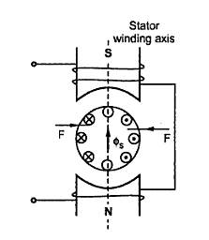
Fig. 5.2
Now Fleming's left hand rule can be used to find the direction of the force experienced by the rotor conductors. It can be seen that when Φ_{s} acts in upward direction and increasing positively, the conductors on left experience force from left to right while conductors on right experience force from right to left. Thus overall, the force experienced by the rotor is zero. Hence no torque exists on the rotor and rotor can not start rotating.
We have seen that there must exist two fluxes separated by some angle so as to produce rotating magnetic field. According to cross field theory, the stator flux can be resolved into two components which are mutually perpendicular. One acts along axis of the stator winding and other acts perpendicular to it.
Assume now that an initial push is given to the rotor anticlockwise direction. Due to the rotation, rotor physically cuts the stator flux and dynamically e.m.f. gets induced in the rotor. This is called speed e.m.f. or rotational e.m.f. The direction of such e.m.f. can be obtained by Flemung's right hand rule and this e.m.f. in phase with the stator flux Φ_{s}. The direction of e.m.f. is shown in the Fig. 5.3. This e.m.f. us denoted as E_{2N}. This e.m.f. circulates current through rotor which is I_{2N}. This current produces its own flux called rotor flux Φ_{r}. This axis of Φ_{r} is at 90º to the axis of stator flux hence this rotor flux is called cross-field.
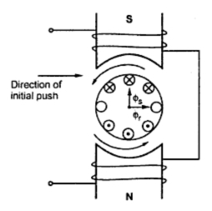
Fig. 5.3

Due to very high rotor reactance, the rotor current I_{2N} and Φ_{r} lags the rotational e.m.f. by almost 90^{o.}
Thus Φ_{r} is in quadrature with Φ_{s} in space and lags Φ_{s} by 90º in time phase. Such two fluxes produce the rotating magnetic field.
The direction of this rotating magnetic field will be same as the direction of the initial push given. Thus rotor experiences a torque in the same direction as that of rotating magnetic field i.e. the direction of initial push. So rotor accelerates in the anticlockwise direction under the case considered and attains a sub-synchronous speed in the steady state.

Equivalent Circuit of Single Phase Induction Motor
The double revolving field theory can be effectively used to obtain the equivalent circuit of a single phase induction motor. The method consists of determining the values of both the fields clockwise and anticlockwise at any given slip. When the two fields are known, the torque produced by each can be obtained. The difference between these two torques is the net torque acting on the rotor.
Imagine the single phase induction motor is made up of one stator winding and two imaginary rotor windings. One rotor is rotating in forward direction i.e. in the direction of rotating magnetic field with slip s while other is rotating in backward direction i.e. in direction of oppositely directed rotating magnetic field with slip 2 - s.
To develop the equivalent circuit, let us assume initially that the core loss is absent.
1. Without core loss
Let the stator impedance be Z Ω
Z = R₁ + j X₁
Where R₁ = Stator resistance
X₁ = Stator reactance
And X₂ = rotor reactance referred to stator
R₂ = rotor resistance referred to stator
Hence the impedance of each rotor is r₂ + j x₂ where
x₂ = X₂/2
The resistance of forward field rotor is r₂/s while the resistance of backward field rotor is r₂ /(2 - s). The r₂ value is half of the actual rotor resistance referred to stator.
As the core loss is neglected, R_{o} does not exist in the equivalent circuit. The x_{o} is half of the actual magnetizing reactance of the motor. So the equivalent circuit referred to stator is shown in the Fig.1.
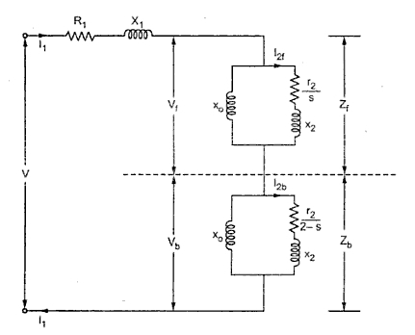
Fig. 1 Equivalent circuit without core loss
Now the impedance of the forward field rotor is Z_{f} which is parallel combination of (0 + j x_{o} ) and (r₂ /s) + j x₂
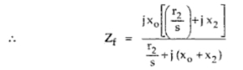
While the impedance of the backward field rotor is Z_{b} which is parallel combination of (0 + j x_{o}) and (r₂ / 2-s) + j x₂.
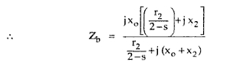
Under standstill condition, s = 1 and 2 - s = 1 hence Z_{f} = Z_{b} and hence V_{f} = V_{b}. But in the running condition, V_{f} becomes almost 90 to 95% of the applied voltage.
... Z_{eq} = Z₁ + Z_{f} + Z_{b} = Equivalent impedance
Let I_{2f} = Current through forward rotor referred to stator
and I_{2b} = Current through backward rotor referred to stator
... I_{2f} = /((r₂/s) + j x₂) where V_{f} = I₁ x Z_{f}
and I_{2b} = /((r₂/2-s) + j x₂)
P_{f} = Power input to forward field rotor
= (I_{2f})² (r₂/s) watts
P_{b} = Power input to backward field rotor
= (I_{2b})² (r₂/2-s) watts
P_{m} = (1 - s){ Net power input}
= (1 - s) (P_{f} - P_{b} ) watts
P_{out} = P_{m} - mechanical loss - core loss
... T_{f} = forward torque = P_{f} /(2πN/60) N-m
and Tb = backward torque = P_{b} /(2πN/60) N-m
T = net torque = T_{f} - T_{b}
while T_{sh} = shaft torque = P_{out} /(2πN/60) N-m
%η = (net output / net input) x 100
2. With core loss
If the core loss is to be considered then it is necessary to connect a resistance in parallel with, in an exciting branch of each rotor is half the value of actual core loss resistance. Thus the equivalent circuit with core loss can be shown as in the Fig. 2.
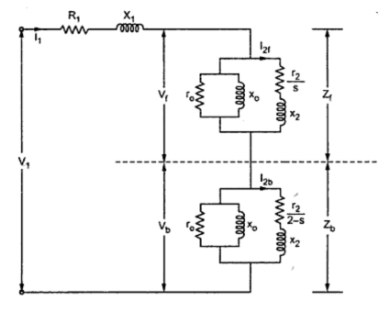
Fig. 2 Equivalent circuit with core loss

Let Z_{of} = Equivalent impedance of exciting branch in forward rotor
= r_{o}║(j x_{o} )
and Z_{ob} = Equivalent impedance of exciting branch in backward rotor
= r_{o}║(j x_{o} )
... Z_{f} = Z_{of} ║( r₂/s + j x₂ )
All other expressions remains same as stated earlier in case of equivalent circuit without core loss.

Determination of Equivalent Circuit Parameters of Single Phase Induction motor
It is possible to find the parameters of the equivalent circuit of the single phase induction motor experimentally as shown in Fig.4.4. For this purpose, three tests should be conducted:
1- The DC Test:
The DC resistance of the stator can be measured by applying DC current to the terminals of the main winding and taking the reading of the voltage and the current (or using ohmmeter) and determine the DC resistance as follows:
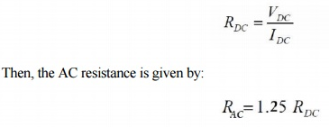

2-The Blocked Rotor Test:
When the rotor is locked (i.e. prevented from running), Sb = Sf = 1. The secondary impedances become much less than the magnetizing branches and the corresponding equivalent circuit becomes that of Fig:.
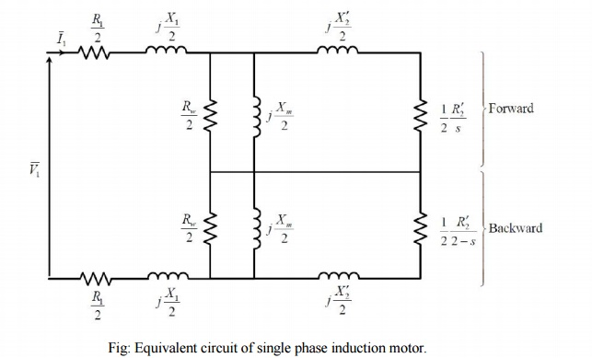
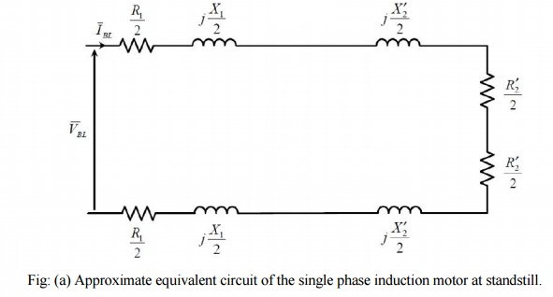

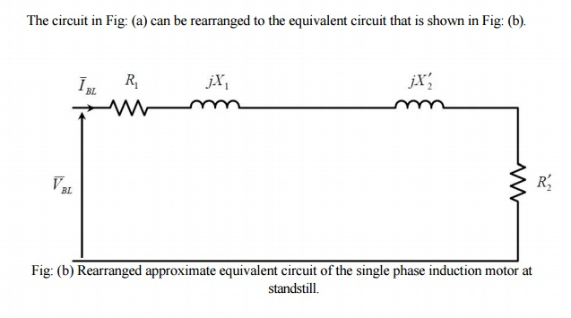

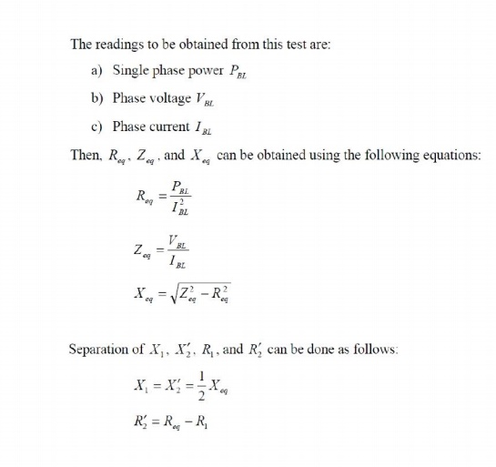

3-The No Load Test:
When the induction motor is allowed to run freely at no load, the forward slip Sf approaches zero and the backward slip Sb approaches 2 (Sf = s, Sb = 2-s). The secondary forward impedance becomes very large with respect to the magnetizing branch, while the secondary backward impedance becomes very small if compared with the magnetizing branch. Accordingly, the equivalent circuit corresponding to these operating conditions can be approximated by that of Fig:.
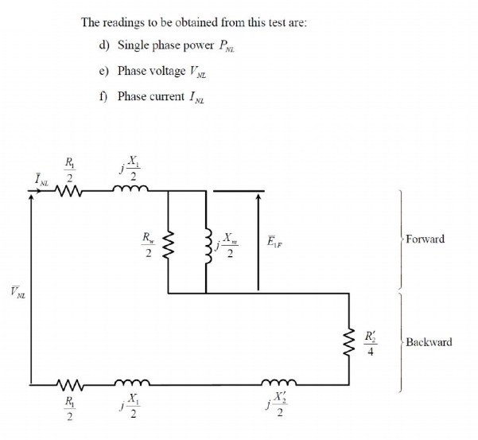
Fig: (a) Approximate equivalent circuit of the single phase induction motor at no load.
The circuit in Fig: (a) can be rearranged to the equivalent circuit that is shown in Fig: (b)
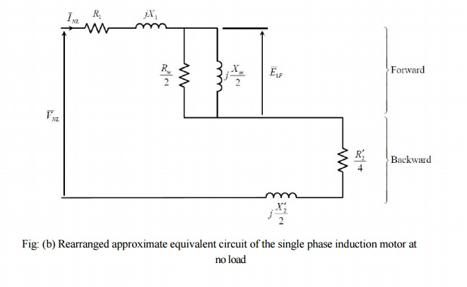
Fig: (b) Rearranged approximate equivalent circuit of the single phase induction motor at no load
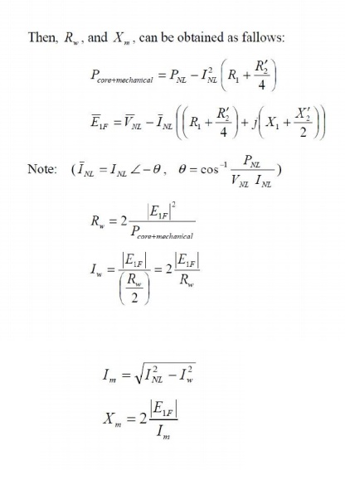

Methods for Making Single Phase Induction as Self Starting Motor
From the above topic we can easily conclude that the single phase induction motors are not self starting because the produced stator flux is alternating in nature and at the starting the two components of this flux cancel each other and hence there is no net torque. The solution to this problem is that if the stator flux is made rotating type, rather than alternating type, which rotates in one particular direction only. Then the induction motor will become self starting. Now for producing this rotating magnetic field we require two alternating flux, having some phase difference angle between them. When these two fluxes interact with each other they will produce a resultant flux. This resultant flux is rotating in nature and rotates in space in one particular direction only. Once the motor starts running, the additional flux can be removed. The motor will continue to run under the influence of the main flux only. Depending upon the methods for making asynchronous motor as Self Starting Motor, there are mainly four types of single phase induction motor namely,
  - Split phase induction motor,
  - Capacitor start inductor motor,
  - Capacitor start capacitor run induction motor,
  - Shaded pole induction motor.
  - Permanent split capacitor motor or single value capacitor motor.

Comparison between Single Phase and Three Phase Induction Motors
Single phase induction motors are simple in construction, reliable and economical for small power rating as compared to three phase induction motors.
The electrical power factor of single phase induction motors is low as compared to three phase induction motors.
For same size, the single phase induction motors develop about 50% of the output as that of three phase induction motors.
The starting torque is also low for asynchronous motors / single phase induction motor.
The efficiency of single phase induction motors is less as compare it to the three phase induction motors.
Single phase induction motors are simple, robust, reliable and cheaper for small ratings. They are generally available up to 1 KW rating.

Types of Single Phase Induction Motor
The single phase induction motors are made self starting by providing an additional flux by some additional means. Now depending upon these additional means the single phase induction motors are classified as:
  - Split phase induction motor.
  - Capacitor start inductor motor.
  - Capacitor start capacitor run induction motor (two value capacitor method).
  - Permanent split capacitor (PSC) motor.
  - Shaded pole induction motor.

Split Phase Induction Motor
In addition to the main winding or running winding, the stator of single phase induction motor carries another winding called auxiliary winding or starting winding. A centrifugal switch is connected in series with auxiliary winding. The purpose of this switch is to disconnect the auxiliary winding from the main circuit when the motor attains a speed up to 75 to 80% of the synchronous speed. We know that the running winding is inductive in nature. Our aim is to create the phase difference between the two winding and this is possible if the starting winding carries high resistance. Let us say I_{run} is the current flowing through the main or running winding, I_{start} is the current flowing in starting winding, and V_{T} is the supply voltage.

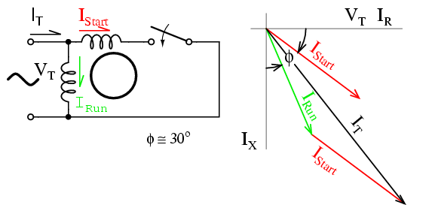
Fig.5.6
We know that for highly resistive winding the current is almost in phase with the voltage and for highly inductive winding the current lag behind the voltage by large angle. The starting winding is highly resistive so, the current flowing in the starting winding lags behind the applied voltage by very small angle and the running winding is highly inductive in nature so, the current flowing in running winding lags behind applied voltage by large angle. The resultant of these two current is I_{T}. The resultant of these two current produce rotating magnetic field which rotates in one direction. In split phase induction motor the starting and main current get split from each other by some angle so this motor got its name as split phase induction motor.

Applications of Split Phase Induction Motor
Split phase induction motors have low starting current and moderate starting torque. So these motors are used in fans, blowers, centrifugal pumps, washing machine, grinder, lathes, air conditioning fans, etc. These motors are available in the size ranging from 1 / 20 to 1 / 2 KW.

Capacitor Start IM and Capacitor Start Capacitor Run IM
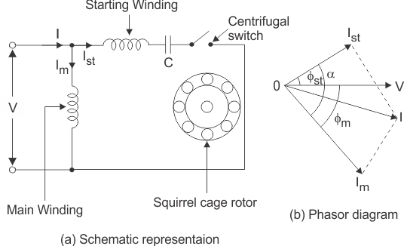
Fig.5.7

The working principle and construction of Capacitor start inductor motors and capacitor start capacitor run induction motors are almost the same. We already know that single phase induction motor is not self starting because the magnetic field produced is not rotating type. In order to produce rotating magnetic field there must be some phase difference. In case of split phase induction motor we use resistance for creating phase difference but here we use capacitor for this purpose. We are familiar with this fact that the current flowing through the capacitor leads the voltage. So, in capacitor start inductor motor and capacitor start capacitor run induction motor we are using two winding, the main winding and the starting winding. With starting winding we connect a capacitor so the current flowing in the capacitor i.e I_{st} leads the applied voltage by some angle, φ_{st}.
The running winding is inductive in nature so, the current flowing in running winding lags behind applied voltage by an angle, φ_{m}. Now there occur large phase angle differences between these two currents which produce an resultant current, I and this will produce a rotating magnetic field. Since the torque produced by these motors depends upon the phase angle difference, which is almost 90º. So, these motors produce very high starting torque. In case of capacitor start induction motor, the centrifugal switch is provided so as to disconnect the starting winding when the motor attains a speed up to 75 to 80% of the synchronous speed but in case of capacitor start capacitors run induction motor there is no centrifugal switch so, the >capacitor remains in the circuit and helps to improve the power factor and the running conditions of single phase induction motor.

Application of Capacitor Start IM and Capacitor Start Capacitor Run IM
These motors have high starting torque hence they are used in conveyors, grinder, air conditioners, compressor, etc. They are available up to 6 KW.

Permanent Split Capacitor (PSC) Motor
It has a cage rotor and stator. Stator has two windings – main and auxiliary winding. It has only one capacitor in series with starting winding. It has no starting switch.
Advantages and Applications
No centrifugal switch is needed. It has higher efficiency and pull out torque. It finds applications in fans and blowers in heaters and air conditioners. It is also used to drive office machinery.

Shaded Pole Single Phase Induction Motors
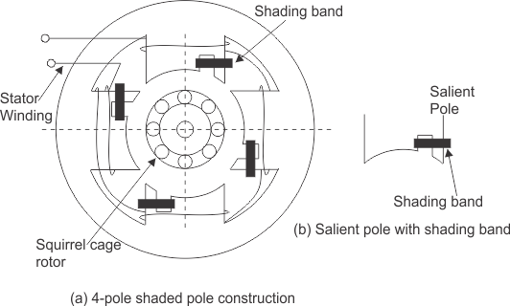
Fig.5.8

The stator of the shaded pole single phase induction motor has salient or projected poles. These poles are shaded by copper band or ring which is inductive in nature. The poles are divided into two unequal halves. The smaller portion carries the copper band and is called as shaded portion of the pole.

ACTION: When a single phase supply is given to the stator of shaded pole induction motor an alternating flux is produced. This change of flux induces emf in the shaded coil. Since this shaded portion is short circuited, the current is produced in it in such a direction to oppose the main flux. The flux in shaded pole lags behind the flux in the unshaded pole. The phase difference between these two fluxes produces resultant rotating flux.
We know that the stator winding current is alternating in nature and so is the flux produced by the stator current. In order to clearly understand the working of shaded pole induction motor consider three regions-
    - When the flux changes its value from zero to nearly maximum positive value.
    - When the flux remains almost constant at its maximum value.
    - When the flux decreases from maximum positive value to zero.
REGION 1:
When the flux changes its value from zero to nearly maximum positive value – In this region the rate of rise of flux and hence current is very high. According to Faraday's law whenever there is change in flux emf gets induced. Since the copper band is short circuit the current starts flowing in the copper band due to this induced emf. This current in copper band produces its own flux. Now according to Lenz's law the direction of this current in copper band is such that it opposes its own cause i.e rise in current. So the shaded ring flux opposes the main flux, which leads to the crowding of flux in non shaded part of stator and the flux weaken in shaded part. This non uniform distribution of flux causes magnetic axis to shift in the middle of the non shaded part.
REGION 2:
When the flux remains almost constant at its maximum value- In this region the rate of rise of current and hence flux remains almost constant. Hence there is very little induced emf in the shaded portion. The flux produced by this induced emf has no effect on the main flux and hence distribution of flux remains uniform and the magnetic axis lies at the center of the pole.
REGION 3:
When the flux decreases from maximum positive value to zero - In this region the rate of decrease in the flux and hence current is very high. According to Faraday's law whenever there is change in flux emf gets induced. Since the copper band is short circuit the current starts flowing in the copper band due to this induced emf. This current in copper band produces its own flux. Now according to Lenz's law the direction of the current in copper band is such that it opposes its own cause i.e decrease in current. So the shaded ring flux aids the main flux, which leads to the crowding of flux in shaded part of stator and the flux weaken in non shaded part. This non uniform distribution of flux causes magnetic axis to shift in the middle of the shaded part of the pole. This shifting of magnetic axis continues for negative cycle also and leads to the production of rotating magnetic field. The direction of this field is from non shaded part of the pole to the shaded part of the pole.

Advantages and Disadvantages of Shaded Pole Motor
The advantages of shaded pole induction motor are
- Very economical and reliable.
- Construction is simple and robust because there is no centrifugal switch.
The disadvantages of shaded pole induction motor are
- Low power factor.
- The starting torque is very poor.
- The efficiency is very low as, the copper losses are high due to presence of copper band.
- The speed reversal is also difficult and expensive as it requires another set of copper rings.

Applications of Shaded Pole Motor
Applications of Shaded pole motors induction motor are Due to their low starting torques and reasonable cost these motors are mostly employed in small instruments, hair dryers, toys, record players, small fans, electric clocks etc. These motors are usually available in a range of 1/300 to 1/20 KW.

Universal Motor - construction, working and characteristics
A universal motor is a special type of motor which is designed to run on either DC or single phase AC supply. These motors are generally series wound (armature and field winding are in series), and hence produce high starting torque. That is why, universal motors generally comes built into the device they are meant to drive. Most of the universal motors are designed to operate at higher speeds, exceeding 3500 RPM. They run at lower speed on AC supply than they run on DC supply of same voltage, due to the reactance voltage drop which is present in AC and not in DC.

Construction of Universal motor
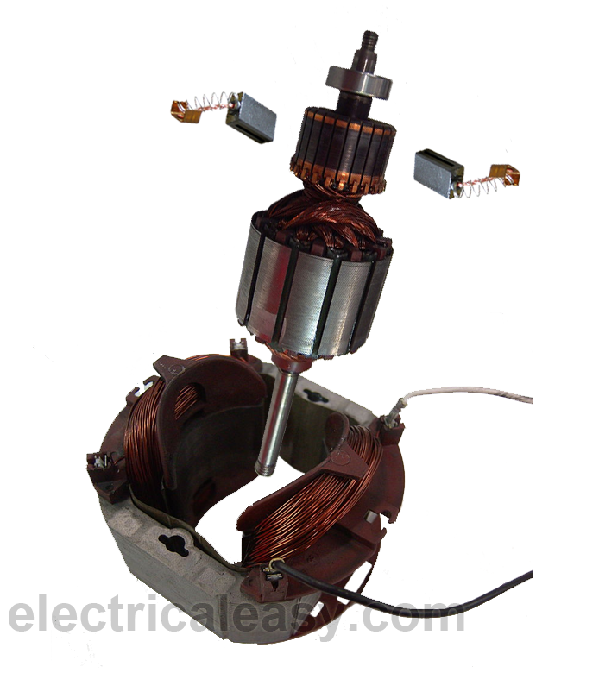
Fig.5.9
Construction of a universal motor is very similar to the construction of a DC machine. It consists of a stator on which field poles are mounted. Field coils are wound on the field poles.
However, the whole magnetic path (stator field circuit and also armature) is laminated. Lamination is necessary to minimize the eddy currents which induce while operating on AC.
The rotary armature is of wound type having straight or skewed slots and commutator with brushes resting on it. The commutation on AC is poorer than that for DC. because of the current induced in the armature coils. For that reason brushes used are having high resistance.
Working of universal motor
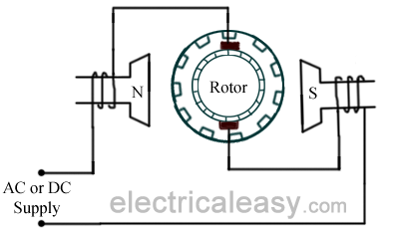
Fig.5.10
A universal motor works on either DC or single phase AC supply. When the universal motor is fed with a DC supply, it works as a DC series motor. When current flows in the field winding, it produces an electromagnetic field. The same current also flows from the armature conductors. When a current carrying conductor is placed in an electromagnetic field, it experiences a mechanical force. Due to this mechanical force, or torque, the rotor starts to rotate. The direction of this force is given by rule. When fed with AC supply, it still produces unidirectional torque. Because, armature winding and field winding are connected in series, they are in same phase. Hence, as polarity of AC changes periodically, the direction of current in armature and field winding reverses at the same time. Thus, direction of magnetic field and the direction of armature current reverses in such a way that the direction of force experienced by armature conductors remains same. Thus, regardless of AC or DC supply, universal motor works on the same principle that DC series motor works.

Speed/load characteristics
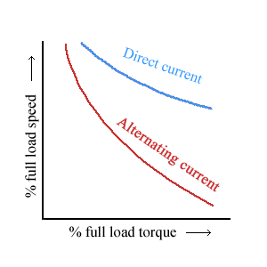
Fig.5.11
Speed/load characteristics of a universal motor is similar to that of DC series motor. The speed of a universal motor is low at full load and very high at no load. Usually, gears trains are used to get the required speed on required load. The speed/load characteristics are (for both AC as well as DC supply) are shown in the figure.

Applications of universal motor
- Universal motors find their use in various home appliances like vacuum cleaners, drink and food mixers, domestic sewing machine etc.
- The higher rating universal motors are used in portable drills, blenders etc.

Repulsion Motor
It may be noted that repulsion motors have excellent characteristics, but are expensive and require more attention and maintenance than single-phase motors. Hence, they are being replaced by two- value capacitor motors for nearly all applications.
Construction:
1. Stator winding of the distributed non-salient pole type housed in the slots of a smooth-cored stator (just as in the case of split-phase motors). The stator is generally wound for four, six or eight poles.
2. A rotor (slotted core type) carrying a distributed winding (either lap or wave) which is connected to the commutator. The rotor is identical in construction to the d.c. armature.
3. A commutator, which may be one of the two types : an axial commutator with bars parallel to the shaft or a radial or vertical commutator having radial bars on which brushes press horizontally.
4. Carbon brushes (fitted in brush holders) which ride against the commutator and are used for conducting current through the armature (i.e. rotor) winding.
Repulsion principle
For understand the torque production by motor using repulsion principle consider a two pole salient pole motor having magnetic axis horizontal. The armature of the machine consists of a d.c. windings having commutator and brushes. The brushes are short circuited by a low resistance jumper.
The stator winding is given excitation in such a way as to form the poles as shown in the Fig.1. The brushes are aligned in the same direction of the field axis. The stator winding will produce alternating flux which will induce e.m.f. in the armature conductors by transformer action. The direction of induced e.m.f. can be found using Lenz's law. The direction of induced current will depend on position of brushes, These currents will lag behind the induced voltage by almost 90º . Because of the current flowing through the armature, it will produce its own magnetic field with the poles as shown in the Fig.1. Thus equal force of repulsion exists between like poles which will not produce any torque.
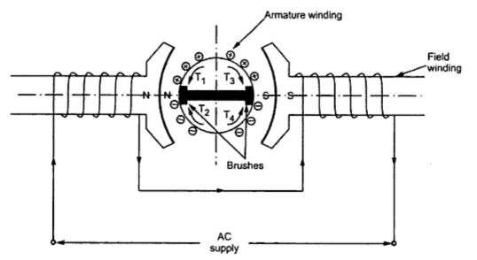
Fig. 1
Alternatively it can be also explained as the armature to be divided into four quadrants producing four torques T₁, T₂, T₃ and T₄ which are equal and hence the net torque is zero
If brushes are shifted by90º , so the conductors undergoing short circuit are also changed. The induced emf are in the same direction as before. The arrangement is shown in the Fig.2.
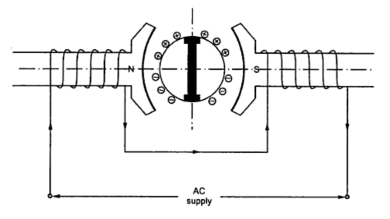
Fig. 2
Apart from the coils undergoing short circuit, the remaining armature winding gets divided into two parallel paths. It can be seen that the induced emfs are balanced and the resultant emf is zero. Thus no current flows through the brushes and the resultant torque is also zero.
If the brushes are in the position shown in the Fig.3. In this case, the brushes axis is not in the line of main field or at an angle of 90º to main field but it is at an angle of α with the main field.
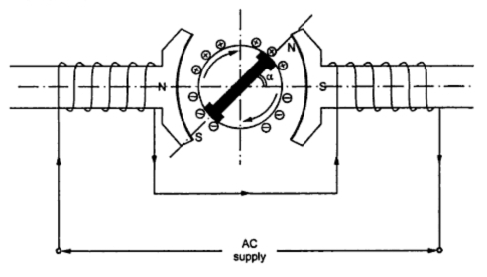
Fig. 3
Again the emf will be induced in the armature conductors and there will be net voltage across brush terminals which will produce current in the armature. Thus the armature will also produce its own magnetic field with the poles as shown in the Fig.3. The north and south poles of stator and rotor will attract each other and there will be net torque available which will run the motor in the clockwise direction. Alternatively we can say that the north pole formed by armature winding will be repelled by the north pole formed by the main field winding and similarly the south pole will be repelled by south pole formed by the main field winding and the motor runs in clockwise direction. As the forces are of repulsion which contributes in the motion so the name of the motor is repulsion motor. If the brush is given shift in the opposite direction to that shown in the Fig.4 then motor runs in anticlockwise direction which can also be explained on the similar lines. Hence the position of brushes decides the direction of rotation. he torque produced by the motor depends on the brush shift angle α.
Thus the control of speed and torque can be done with the help of brush shift. The variation of torque with brush shift is shown in the Fig.4.
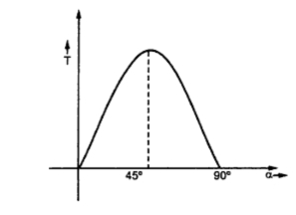
Fig. 4 α = 45º maximum torque is available
Principal shortcomings of such a motor are:
1. Speed varies with changing load, becoming dangerously high at no load.
2. Low power factor, except at high speeds.
3. Tendency to spark at brushes.
Stepper (Or Stepping) Motors
The stepper or stepping motor has a rotor movement in discrete steps. The angular rotation is determined by the number of pulses fed into the control circuit. Each input pulse initiates the drive circuit which produces one step of angular movement. Hence, the device may be considered as a digital-to-analogue converter.
There are three most popular types of rotor arrangements:
1. Variable reluctance (VR) type
2. Permanent magnet (PM) type
3. Hybrid type, a combination of VR and PM.

Step Angle
The angle by which the rotor of a stepper motor moves when one pulse is applied to the stator (input) is called step angle. This is expressed in degrees. The resolution of positioning of stepper motor is decided by the step angle. Smaller the step angle the higher is the resolution of positioning of the motor. The step number or resolution of a motor is the number of steps it makes in one revolution of the rotor.
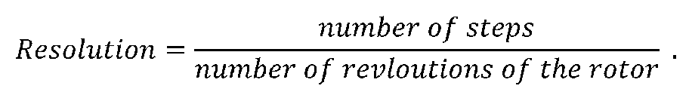
Higher the resolution, grater is the accuracy of positioning of objects by the motor. Stepper motor is realizable for very small step angles. Some precision motors can make 1000 steps
in one revolution with a step angle of 0.36 A standard motor will have a step angle of 1.8 with 200 steps per revolution.

Variable Reluctance (VR) Stepper Motor
A variable reluctance (VR) stepper motor can be of single stack type or the multi-stack type.

i) Single-Stack Variable Reluctance Motor
A Variable reluctance stepper motor has salient-pole (or tooth) stator. The stator has concentrated winding places over the stator poles (teeth). The number of phases of the stator
depends upon the connection of stator poles. Usually three or four phases winding are used. The rotor is slotted structure made from ferromagnetic material and carries no winding. Both the stator and rotor are made up of high quality magnetic materials having very high permeability so that the exciting current required is very small. When the stator phases are excited in a proper sequence from dc source with the help of semiconductor switch, a magnetic field is produced. The ferromagnetic rotor occupies the position which presents minimum reluctance to the stator field. That is, the rotor axis aligns itself to the stator field axis. Elementary operation of variable reluctance motor can be explained through the diagram of fig. 1.
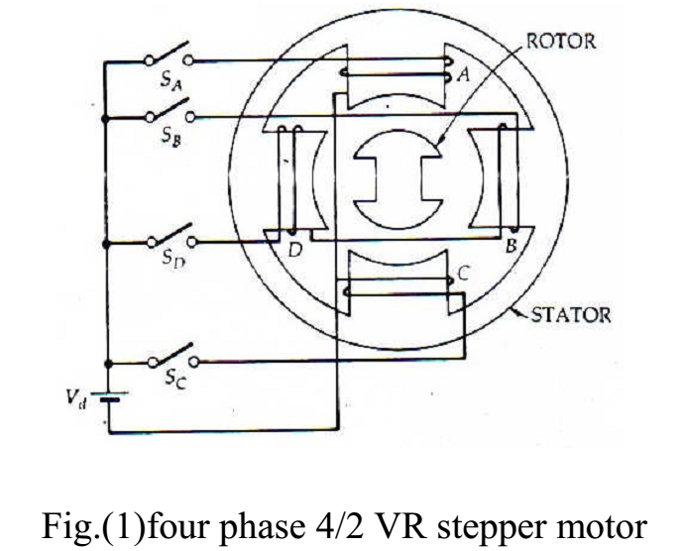

It is a four-phase, 4/2-pole (4 poles in the stator and 2 in the rotor), single-stack, variable reluctance stepper motor. Four phases are A, B, C and D are connected to dc source with the
help of semiconductor switches S_{A}, S_{B}, S_{C} and S_{D} respectively. The phase winding of the stator are energised in the sequence A, B, C, D, A. When winding A is excited, the rotor aligns with the axis of phase A. The rotor is stable in this position and cannot move until phase A is de-energised. Next, phase B is excited and A is disconnected. The rotor moves through 90 in clockwise direction to align with the resultant air gap field which now lies
along the axis of phase B. Further, phase C is excited and B is disconnected, the rotor moves through a further step of 90 in the clockwise direction. In this position, the rotor aligns with the resultant air gap field which now lies along the axis of phase C. Thus, as the phases are excited in the sequence A, B, C, D, A the rotor moves through a step of 90 at each transition in clockwise direction. The rotor completes one revolution through four steps. The direction of rotation can be reversed by reversing the sequence of switching the winding that is A, D, C, B, A. it is seen that the direction of rotation depends only on the sequence of switching the phases and is independent of the direction of currents through the phases.
The magnitude of step angle for any VR and PM stepper motor is given by
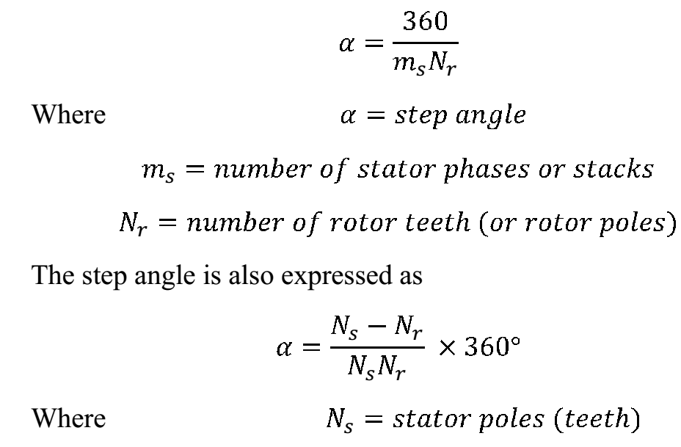
The step angle can be reduced from 90 to 45 by exciting phases in the sequence A, A+B , B , B+ C , C, C+ D , D, D + A, A. Here (A+B) means that phase winding A and B are excited
together and the resultant stator field will be midway between the poles carrying phase winding A and B. That is, the resultant field axis makes an angle of 45 with the axis of pole A in the clockwise direction. Therefore when phase A is excited, the rotor aligns with the axis of phase A. when phases A and B are excited together, the rotor moves by 45 in the clockwise direction. Thus, It is seen if the windings are excited in the sequence A, A+ B, B, B+ C, C, C+ D, D, D+A, A the rotor rotates in steps of 45 in the clockwise direction. The rotor can be rotated in steps of 45 in the anticlockwise direction by exciting the phase in the sequence A, A + D, D, D + C, C, C + B, B, B + A, A. this method of gradually shifting excitation from one phase to another (for example, from A to B with an intermediate step of A+ B) is known as micro stepping. It is used to realize smaller steps. Lower values of step angle can be obtained by using a stepping motor with more number of poles on stator and
teeth on rotor. Consider a four-phase, 8/6 pole, single stack variable reluctance motor shown in fig 2.
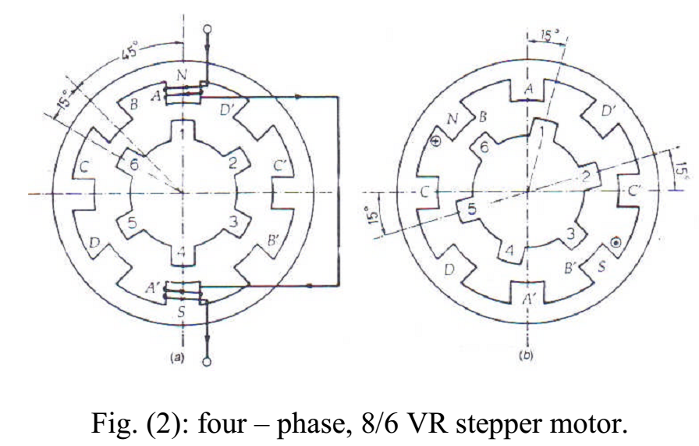
The coils wound around diametrically opposite poles are connected in series and four circuits (phase) are found. These phases are energised from a dc source through electronic switching device. The rotor has six poles (teeth). For the sake of simplicity, only phase A winding is shown in fig (2-a). when phase A (coil A-A`) is excited, rotor teeth numbered 1 and 4 aligned along the axis of phase A winding. Next phase winding A is de-energised and phase winding B is excited. Rotor teeth numbered 3 and 6 get aligned along the axis of phase B and the rotor moves through a step angle of 15 in the clockwise direction. Further clockwise rotation of 15 is obtained by deenergising phase winding B and exciting phase winding C. with the sequence A, B, C, D, A, four steps of rotation are completed and the rotor moves through 60 in clockwise direction. For one complete revolution of the rotor, 24 steps are required. For anticlockwise rotation of rotor through each step of 15, the phase windings are excited in reverse sequence of A, D, C, B, A.

ii) Multi-Stack Variable Reluctance Stepper Motor
A multi-stack (or m-stack) variable reluctance stepper motor can be considered to be made up of m identical single stack variable reluctance motors with their rotors mounted on a single shaft. The stators and rotors have the same number of poles (or teeth) and, therefore, same poles pitch. For m-stack motor, the stator poles in all m stacks are aligned, but the rotor
poles are displaced by 1/m of the pole pitch angle from one another. All the stator pole windings in given stack are excited simultaneously and, therefore, the stator winding of each stack forms one phase. Thus, the motor has the same number of phases as the number of stacks.
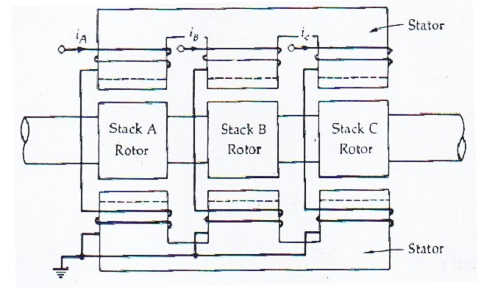
Fig.3 shows the cross-section of a three-stack (three-phase) motor parallel to the shift. In each stack, stators and rotors have 12 poles. For a 12-pole rotor, the pole pitch is 30, and therefore
the rotor poles are displaced from each other by one-third of the pole pitch or 10⁰ . The stator teeth in each stack are aligned. When the phase winding A is excited rotor teeth of stack A are aligned with the stator teeth as shown in fig. (4-a).
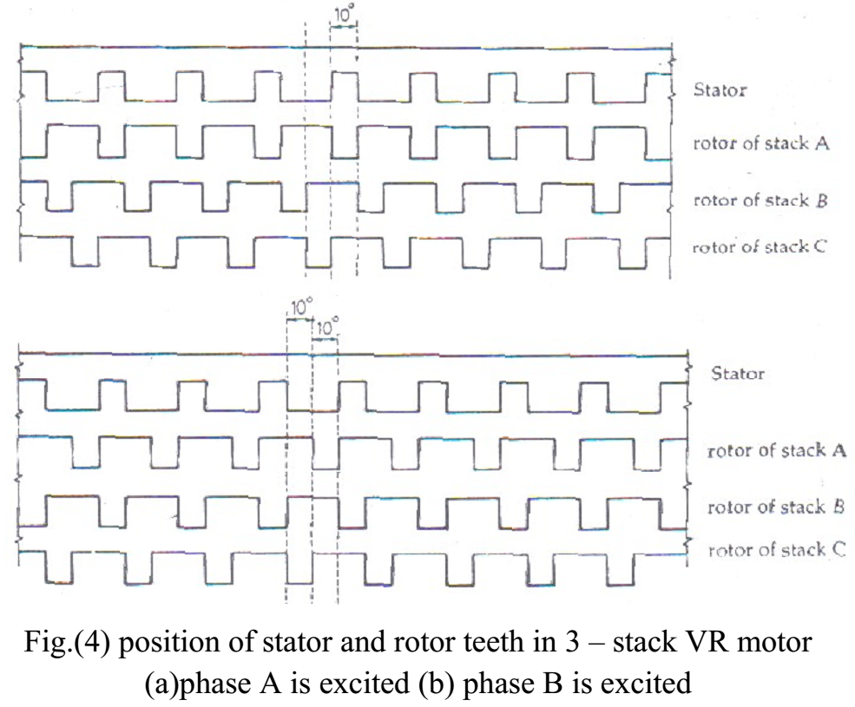

When phase A is de-energized and phase B is excited, rotor teeth of stack B are aligned with stator teeth. This new alignment is made by the rotor movement of 10⁰ in the anticlockwise direction. Thus the motor moves one step (equal to 1/3 pole pitch) due to change of excitation from stack A to B (fig.4-b).
Next phase B is de-energized and phase C is excited. The rotor moves by another step of one-their of pole pitch in the anticlockwise direction. Another change of excitation from stack
C to stack A will once more align the stator and rotor teeth in stack A. however, during this process 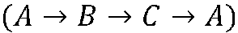 the rotor has move one rotor tooth pitch.
Let Nr be the number of rotor teeth and m the number of stacks or phases.
Then
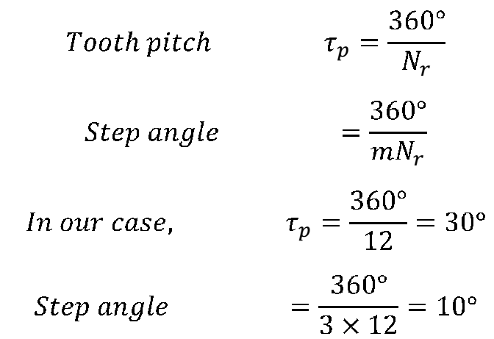
Multi-stack variable reluctance stepper motors are widely used to obtain smaller step size, typically in the range of 2 to 15 degrees.
The variable reluctance motors, both single and multi-stack type, have high torque to inertia ratio. The reduced inertia enables the VR motor to accelerate the load faster.

Advantages of Stepper Motor:
- The rotation angle of the motor is proportional to the input pulse.
- The motor has full torque at standstill.
- Precise positioning and repeatability of movement since good stepper motors have an accuracy of 3 – 5% of a step and this error is non cumulative from one step to the next.
- Excellent response to starting, stopping and reversing.
- Very reliable since there are no contact brushes in the motor. Therefore the life of the motor is simply dependant on the life of the bearing.
- The motors response to digital input pulses provides open-loop control, making the motor simpler and less costly to control.
- It is possible to achieve very low speed synchronous rotation with a load that is directly coupled to the shaft.
- A wide range of rotational speeds can be realized as the speed is proportional to the frequency of the input pulses.

Applications:
- Industrial Machines – Stepper motors are used in automotive gauges and machine tooling automated production equipments.
- Security – new surveillance products for the security industry.
- Medical – Stepper motors are used inside medical scanners, samplers, and also found inside digital dental photography, fluid pumps, respirators and blood analysis machinery.
- Consumer Electronics – Stepper motors in cameras for automatic digital camera focus and zoom functions.

